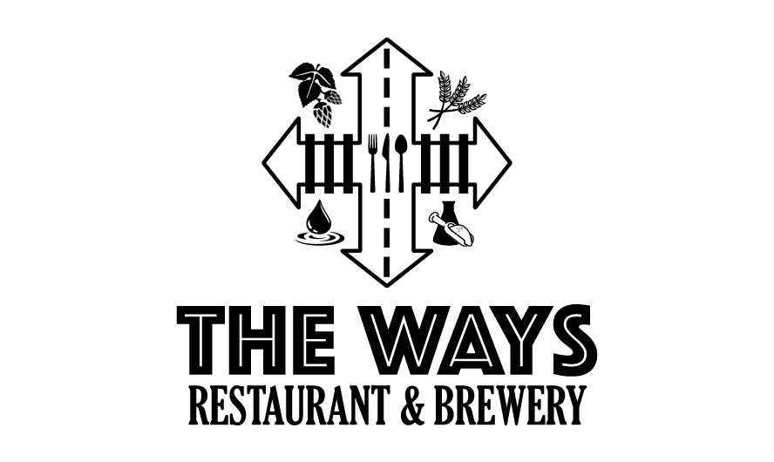

***Restaurant Week Menu***

***Winter Salad***

Spring mix with toasted almonds, dried cranberries, blue cheese crumbles, served with balsamic vinaigrette.

***Carrot Ginger Soup***

Carrots, ginger, and warming spices blended smoothly and topped with Aleppo pepper and cilantro.

***Birria Eggrolls***

Shredded beef braised with ancho chilis, and spices wrapped in an eggrollwrapper with white onion and cilantro. Served with consommé.

***Beef Stew***

Beef stew made with our house brewed stout served over mashed potatoes.

All of the above for $42